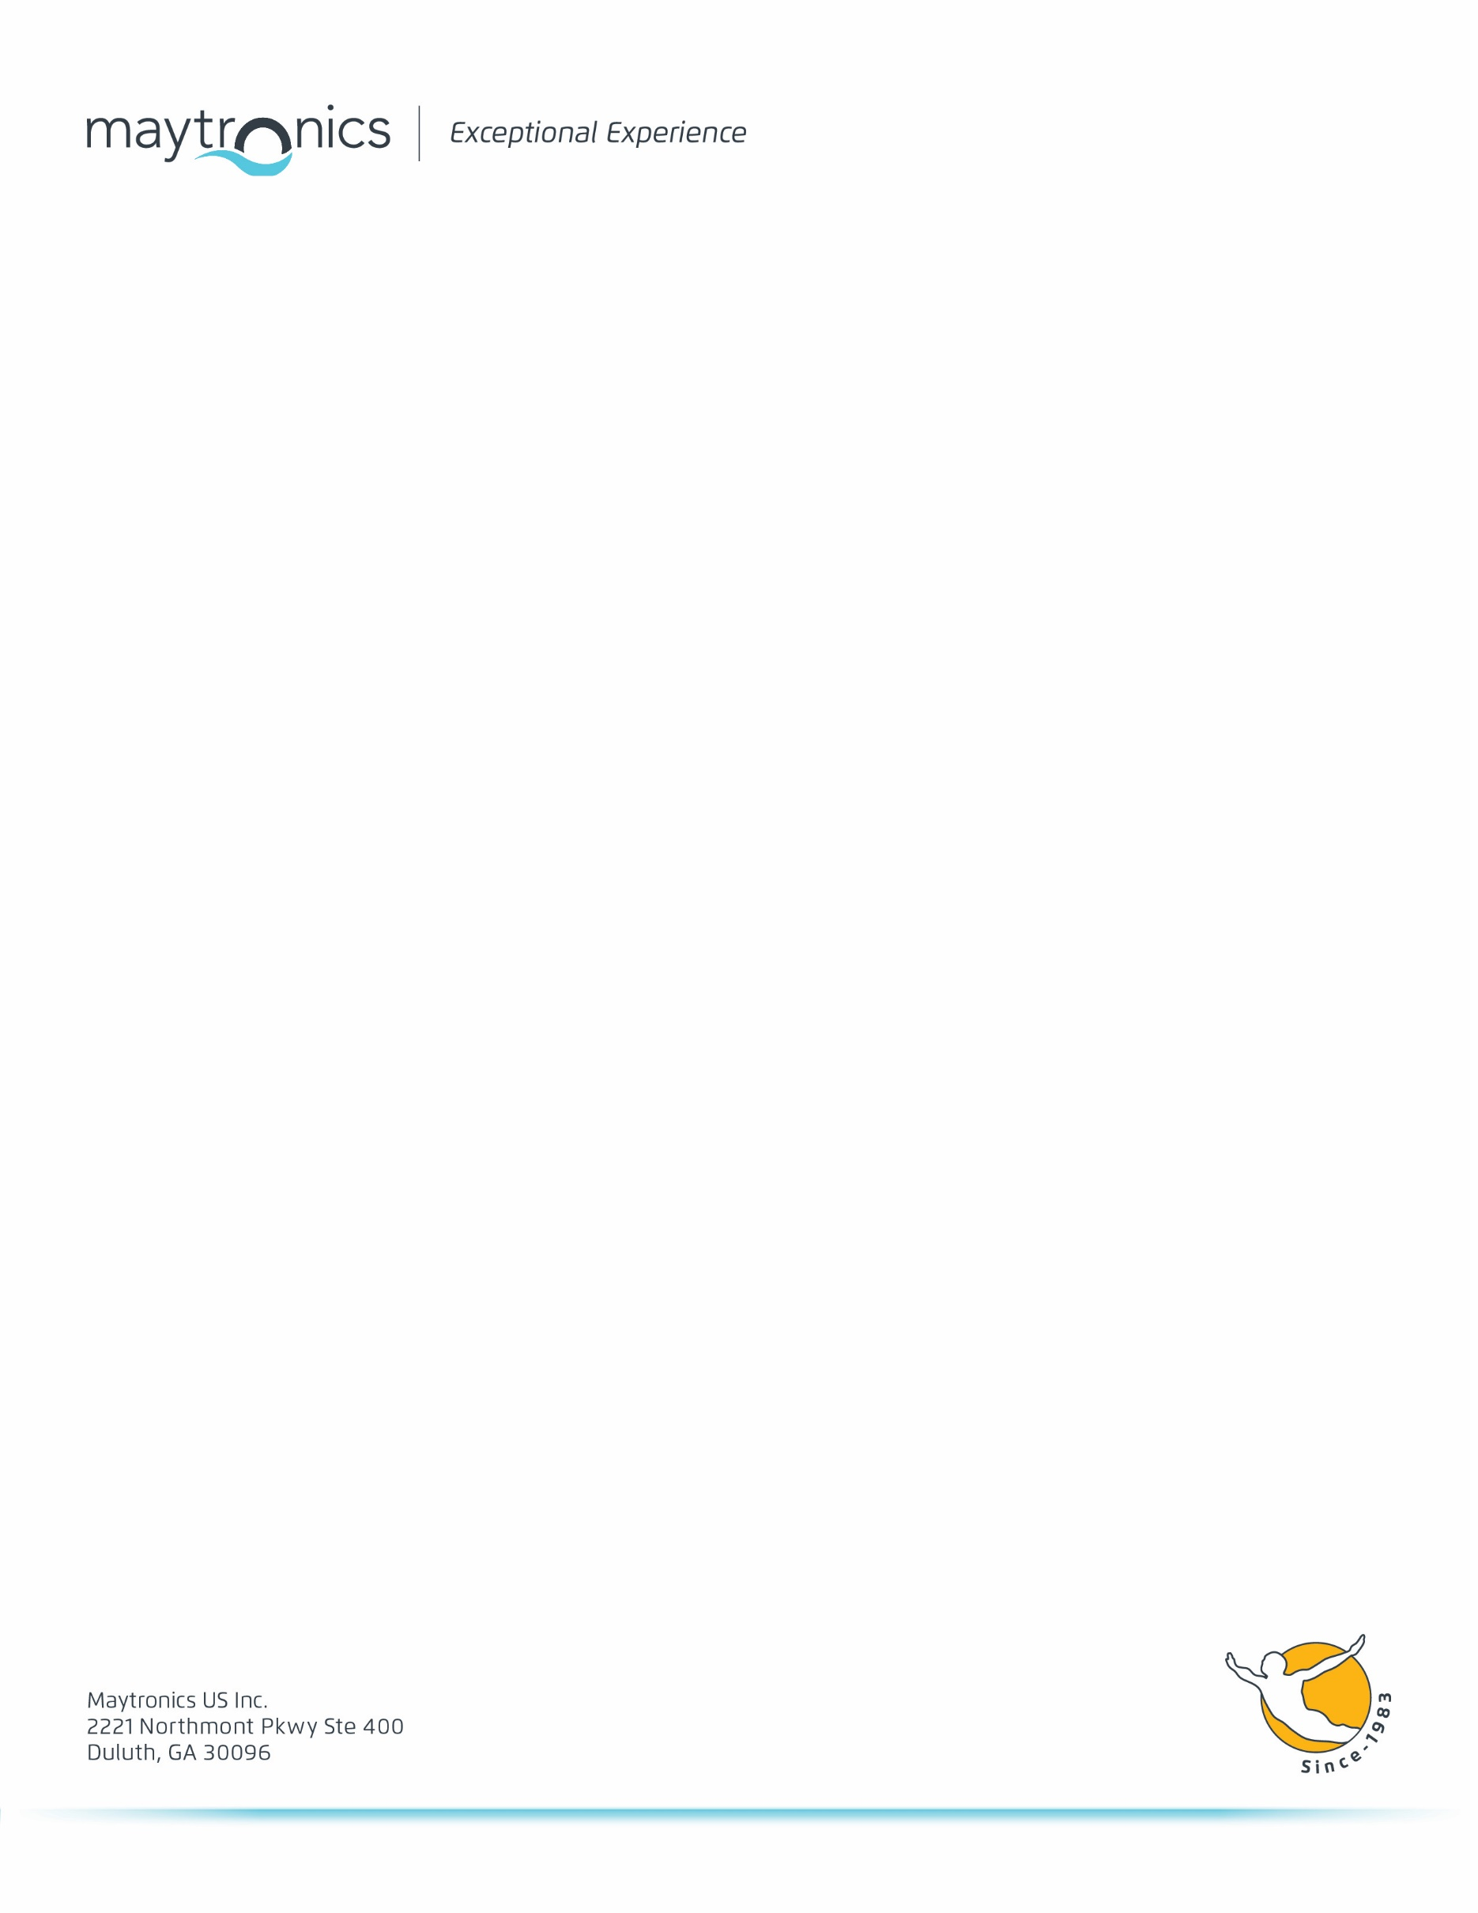

## **Dolphin Pool Cleaner Warranty**

[MAYTRONICS LTD]  
LIMITED WARRANTY

[Maytronics LTD] (“Maytronics”) warrants that your DOLPHIN pool cleaner will be free from defects in material and workmanship for the indicated warranty period for any Maytronics Dolphin pool cleaner subject to qualifications, conditions and limitations as described below.

If, during the applicable warranty period, this product proves to be defective, Maytronics will remedy the defect by either repairing or replacing the product or any of its defective parts or components, at Maytronics option. Such repair or replacement may include the use of refurbished components and/or units at the option of Maytronics. Maytronics also reserves the right to use substitute units, parts or components of comparable value and design for any discontinued designs.

For service, contact Maytronics at [www.maytronics.com.](http://www.maytronics.com/)

Warranty claims require proof of purchase and confirmation from you that you are the original consumer purchaser of the Dolphin pool cleaner. If shipping to an authorized service center is required, freight must be paid by purchaser, and the purchaser should attach with the unit a copy of the purchase invoice including date of purchase, serial number and description of the problem.

All shipping and transportation costs and damages are excluded from this warranty.

This warranty is not transferable and applies only to the original consumer purchaser, and only to units that are purchased and used within North America. Your Dolphin pool cleaner is designed to work in water with up to 5000 P.P.M. of salt. The use of the unit in water over 5,000 P.P.M. of salt will void the warranty.

This warranty covers only normal and reasonable use of the unit. The warranty is for manufacturing defects only. Damage, defects, malfunctions or other failures or any use which does not comply with the instructions in the Operator’s manual, including the failure of the purchaser to provide reasonable and necessary maintenance, shall void this warranty. Damage, defects, malfunctions or other failures caused by or related to repairs performed by any service station or person other than an authorized service representative of Maytronics shall not be covered.

The use of any electrical components other than originally manufacturer by Maytronics will void the warranty.

Exclusions - normal wear to Wonder Brushes, Combined Brushes and filter bags are excluded from this warranty.

MAYTRONICS SHALL NOT BE LIABLE OR RESPONSIBLE UNDER ANY CIRCUMSTANCES OR IN ANY AMOUNT FOR ANY CONSEQUENTIAL OR INCIDENTAL DAMAGES, OR FOR ANY INJURY OR DAMAGES TO PERSONS OR PROPERTY USING OR USED IN CONNECTION WITH THE PRODUCT, OR FOR LOSS OF PROFIT OR OTHER COSTS OR EXPENSES OF ANY KIND OF CHARACTER, INCLUDING WITHOUT LIMITATION, ANY AND ALL CLAIMS FOR DAMAGES TO ANY POOL PLASTER OR VINYL LINER IN PURCHASER’S POOL BY REASON OF THE USE AND/OR OPERATION FO THE DOLPHIN POOL CLEANER.

Some states do not allow the exclusion or limitation of incidental or consequential damages, so the above limitation or exclusion may not apply to you.

THE DURATION OF ANY IMPLIED WARRANTIES ARE LIMITED TO THE DURATION FO THE COVERAGE PROVIDED BY THIS LIMITED WARRANTY AS INDICATED INT HE ABOVE CHART; PROVIDED, HOWEVER, THAT NOTHING IN THIS LIMITED WARRANTY SHALL GIVE YOU ANY IMPLIED WARRANTIES YOU WOULD NOT OTHERWISE HAVE, EXTEND THE SAME BEYOND THEIR CUSTOMARY DURATION, OR MAKE MAYTRONICS LIABLE FOR ANY IMPLIED WARRANTIES THAT IT WOULD NOT BE LIABLE FOR IF THIS LIMITED WARRANTY HAD NOT BEEN GIVEN.

Some states do not allow limitations on how long an implied warranty lasts, so the above limitation may not apply to you.

This warranty gives you specific legal rights, and you may also have other rights which vary from state to state.